Supplemental Text 1

In many fisheries, and especially in resource-limited fisheries, it may not be feasible to conduct extensive stock assessments and develop and apply comprehensive fishery management plans for every species being impacted by the fishery all at the same time. Instead, it is necessary to focus first on a subset of species in need of the most immediate attention and create a plan to come back to the other species later. In other words, it’s necessary to conduct a species prioritization exercise. The question remains how should we distinguish those species that are in greatest need of our attention sooner from those that can wait a bit before they are closely examined? Many factors might go into this decision but we recommend basing it on: 1) the relative vulnerability of each species caught in the fishery to overfishing (Patrick et al., 2009); 2) the current health/ depletion status of each species (because just because a target is less vulnerable to the fishery, that doesn’t mean it is necessarily currently in good health; EDF, 2021); and 3) the social, economic, and biophysical “value” of each species. In addition to all of these factors, climate change is likely to impact different species in different ways, and it is thus valuable to incorporate this information into the prioritization process (see supplemental text – fish basket climate change).

Below are the steps the walk through a matrix approach, to prioritizie species for further assessment and precautionary management using FISHE (EDF, 2021; Figure S1). First, the relative vulnerability of overfishing for each species caught in the fishery (whether targeted or bycatch) is assessed using a PSA (or FISHE Step 4; Patrick et al., 2009; Cope et al., 2011) and an estimate of species status (low, medium, or high) from FISHE Step 5 are combined to organize each of the species impacted by the fishery into a matrix. This matrix then guides the prioritization of target species for further assessment and/or precautionary management. This prioritization process can help to produce management guidance for each species with each combination of vulnerability and depletion levels. Then, climate vulnerability information from FISHE Step 1 can be overlaid onto this current prioritization matrix to help inform decisions and actions aimed at fishery system resilience-building. An example of this approach is given below in the Table: 1 Prioritization Matrix.

**FISHE Step 6,Table 1a: Prioritization Matrix**

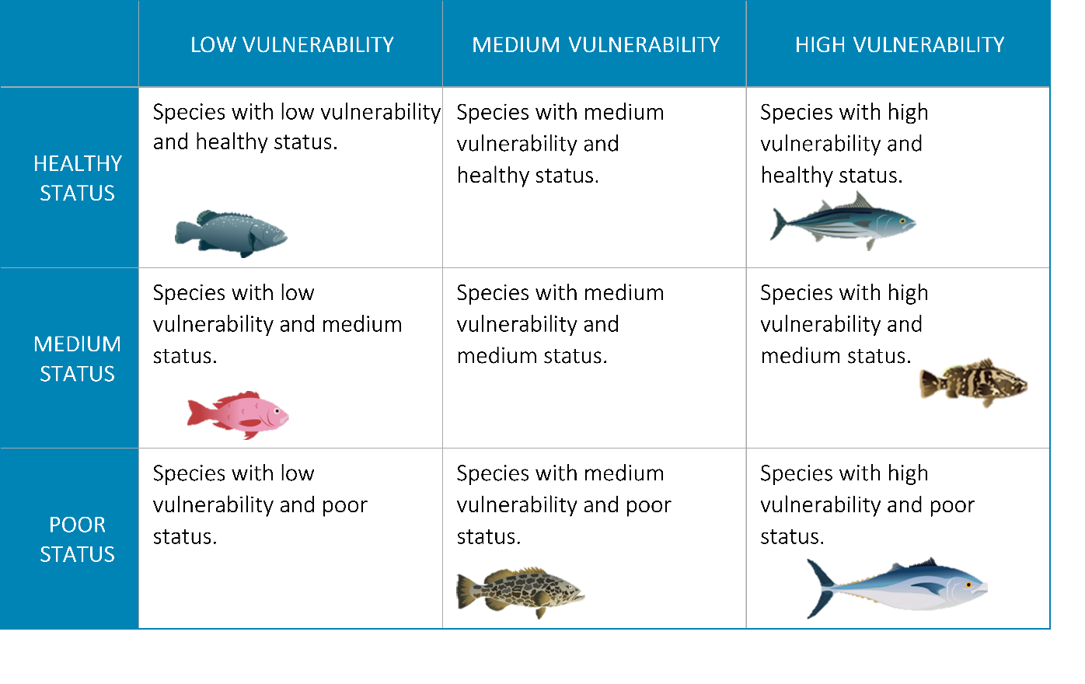

For truly multispecies fisheries, where many species are caught all together with the same gear, this organization process can form the basis of the creation of species management “baskets,” or “tiers,” that can be used to implement a management strategy that involves applying different harvest controls to different categories of stocks based on their vulnerability to overfishing and their estimated depletion status. This approach, called fish baskets, is aimed at preventing the depletion of species that are not very productive and/or highly susceptible to fishing. This type of depletion often occurs sequentially, with large slow-growing highly valuable fish being depleted first, followed by species that are somewhat more productive and/or less valued, etc. until fisheries are left with few options but to target highly productive but low value species. This phenomenon is called “serial depletion,” or sometimes “fishing down the food web.” Serial depletion reduces fishing opportunities and can have adverse impacts on marine ecosystems.

The steps for the fish basket process are: organize, prioritize and select, and operationalize. In the fish baskets approach, species are first **organized** into the 9 cells of Table 1a, band then managers, scientists, and stakeholders consider several factors in order to put species in the right management baskets: fishery vulnerability and depletion (i.e. location in the table); stakeholder risk tolerance (i.e. how much risk of serial depletion are you willing to tolerate?); value (commercial and social); how would each basket of species be managed in practice (e.g., if they are caught together with the same gear, maintaining fishing mortality at target levels is more feasible than if the species are caught with different types of gear); social and cultural relevance, or ecosystem (either where it is fished, or resilience strategies). In other words, stakeholders can choose to manage each cell of the table as its own basket, adjacent cells can be combined to generate fewer baskets that each have wider vulnerability and/or depletion ranges, or species can be “pulled out” of cells and managed on their own (potentially resulting in more than 9 baskets, see Table 1b). Once species have been organized into

**FISHE Step 6, Table 1b: Basic Fish Baskets**

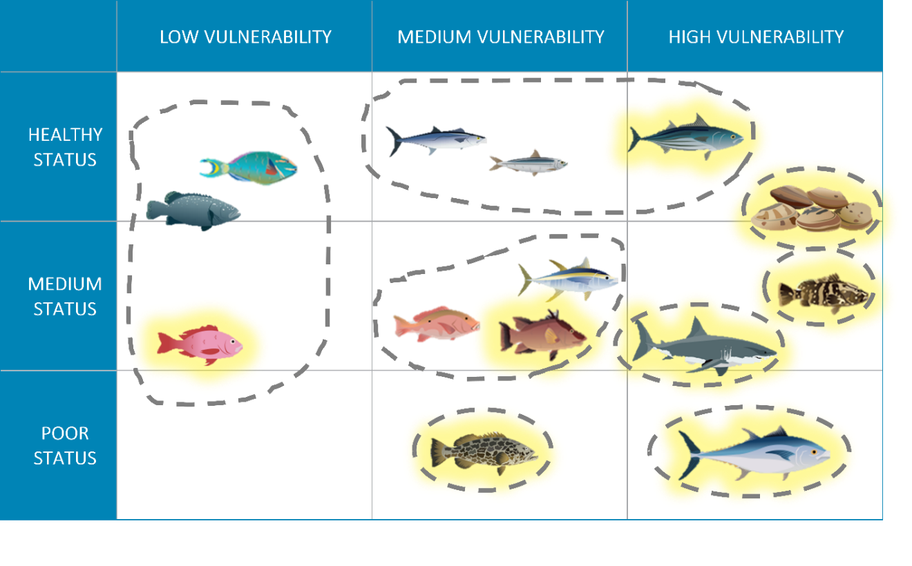

Once species have been organized by vulnerability and depletion (and management baskets have been created/ representative species selected if working in a multispecies fishery), managers, scientists, and fishers can work together to agree on an appropriate prioritization scheme – i.e. which cells/ baskets should be considered a high priority for further assessment and potentially immediate precautionary management, which are low priority, and can continue to be fished as they have been without additional examination or management action in the immediate term, and which fall in the middle of this spectrum. In fish baskets, one or more representative species can be **prioritized and selected** from each basket for which further assessments can be conducted (FISHE Steps 7-9) and management measures defined (FISHE Steps 10 and 11). A similar approach has been used in Australian waters, where the selection of ‘indicator’ species are used to assess the risk to sustainability of all ‘like’ species susceptible to capture within a fishery resource (Newman et al., 2018). The process of using an indicator species is now widely understood and accepted by stakeholders, focusing fishery dependent and/or independent- monitoring, biological sampling, stock assessment and compliance priorities. Representative/indicator species can be chosen based on data availability, individual vulnerability and depletion scores (i.e., scores at the high end for its basket, or right in the middle of other species in the basket, depending on your risk tolerance), life history similarity to other species in the basket (if known) and/ or value to the fishery. We also strongly recommend incorporating climate vulnerability information into this process of selecting management basket representative species. See Tables 2a and 2b for examples.

After fish baskets are prioritized for management and indicator species have been determined a range of fishery management regimes are designated for each fish basket and the indicator species, with harvest control rules and measures identified for each fish basket. This is the process of **operationalizing** each fish basket. Harvest control rules are developed to define adjustments in fishing mortality necessary to maintain indicators near target levels, and harvest measures appropriate for each stock complex are promulgated to implement the harvest control rules. Indicator levels are monitored and compared with targets and limits annually to enable adaptive management. Management guidance can also be developed for each cell, basket, or prioritization class (i.e., all the “Medium Priority” cells) at this time. Conversations with local fishery stakeholders and managers to determine correct management guidance for each cell/basket is recommended. Management guidance will vary depending on the value of the species(s) for fishing and for other uses (e.g., tourism, recreational fishing or ecological role), risk tolerance and special status (i.e., threatened or endangered species).

**FISHE Step 6, TABLE 2a**: Precautionary management recommendations.

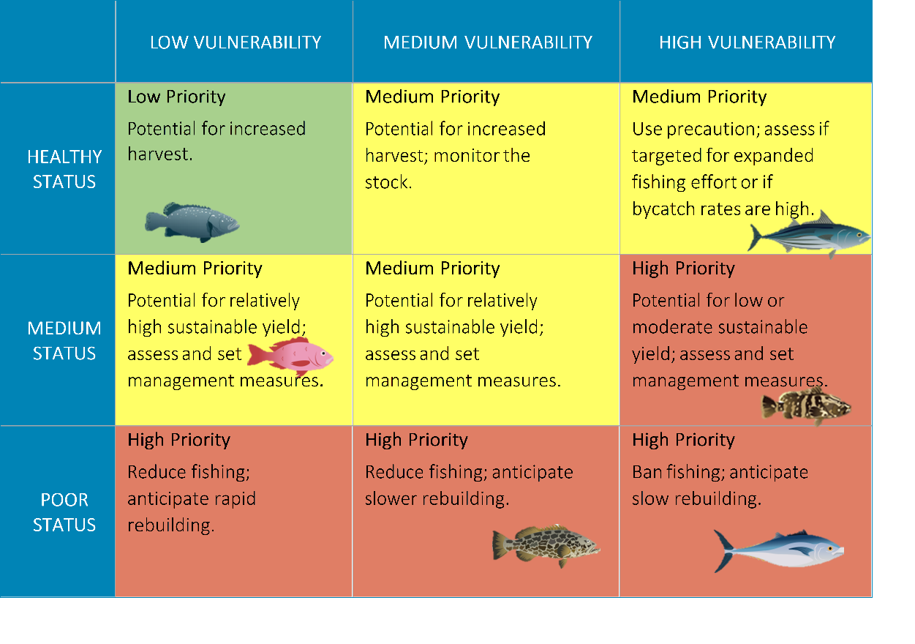

**FISHE Step 6, Table 2b:** Prioritization matrix with management baskets.

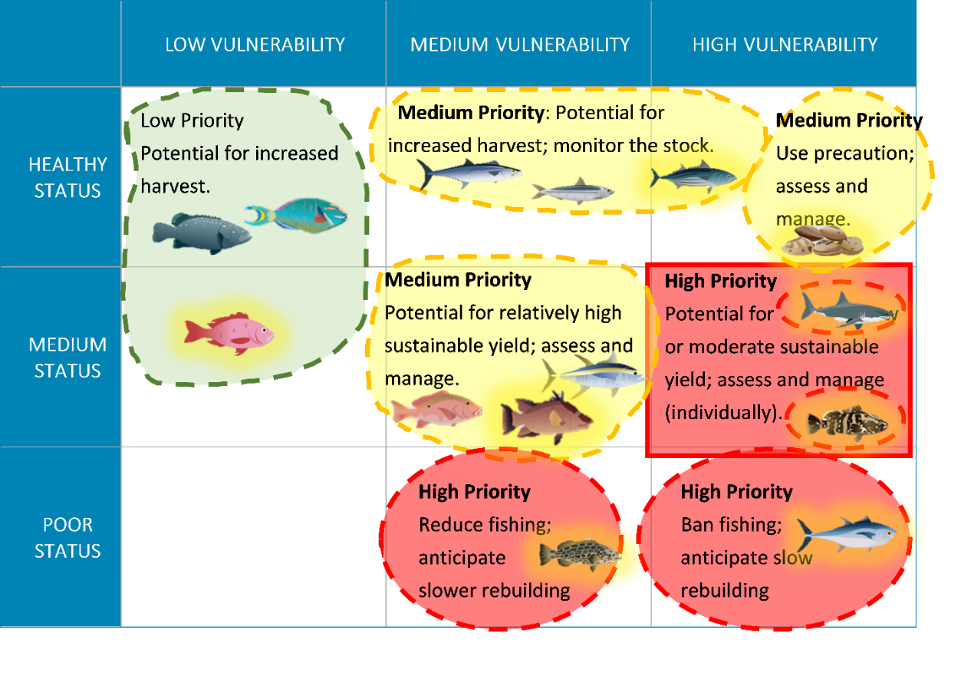

When working with management baskets in a multispecies fishery, managers may choose to prioritize and generate management guidance based on baskets rather than based on cells of the species organization matrix. Note that doing so may result in different guidance for some species than would have been provided based on individual cells, depending on how baskets are created, and which species are selected as representatives. For instance, in the example above, with management baskets organized as in Table 2b, the skipjack tuna and the silk snapper have both be assigned different guidance (”Potential for increased harvest”) than they would have been based on Table 2a, above, because they are grouped into baskets with species in different cells of the table. Note also that in each case where the determination is made that more assessment and/or monitoring is warranted, only the representative species for that basket (the species highlighted in yellow) would actually be assessed and monitored, and its scores and results would be used to make decisions about all species in its basket.

References

Cope, J. M., DeVore, J., Dick, E. J., Ames, K., Budrick, J., Erickson, D. L., et al. (2011). An Approach to Defining Stock Complexes for U.S. West Coast Groundfishes Using Vulnerabilities and Ecological Distributions. N. Am. J. Fish. Manag. 31:4, 589–604. doi: 10.1080/02755947.2011.591264

Environmental Defense Fund (2021). FISHE: Framework for Integrated Stock and Habitat Evaluation. http://fishe.edf.org/. [Accessed April 15, 2021].

Newman, S., Brown, J., Fairclough, D., Wise, B., Bellchambers, L., Molony, B., et al. (2018). A Risk Assessment and Prioritisation Approach to the Selection of Indicator Species for the Assessment of Multi-Species, Multi-Gear, Multi-Sector Fishery Resources. Mar. Policy. 88, 11-22. doi: 10.1016/j.marpol.2017.10.028

Patrick, W. S., Spencer, P., Ormseth, O., Cope, J., Field, J., and Kobayashi, D. (2009). Use of Productivity and Susceptibility Indices to Determine Stock Vulnerability, with Example Applications to Six U.S. Fisheries. U.S. Dep. Commer., NOAA Tech. Memo. NMFS-F/SPO-101, 90.

Supplemental Text 2

Different species respond differently to climate change impacts, and this can affect priority setting and management. For this reason, the Fish Basket approach strongly recommends that information about species’ individual vulnerabilities to climate change also be considered during this prioritization process of FISHE (Supplemental Figure FISHE). Climate vulnerability can be estimated with a formal species-by-species Climate Vulnerability Analysis (e.g., see Method 3 under FISHE Step 1; EDF 2021a), or, if that level of data is unavailable, it can be inferred from an understanding of system-level climate impacts and a more qualitative thought exercise to consider each species’ likely tolerance of/ adaptability to these system changes (e.g., see the questions provided in the Appendix to the Climate Impact Profile Template – Method 1, FISHE Step 1; EDF 2021). Species that are determined to be the most vulnerable to climate changes should be highlighted at this step for further monitoring and evaluation. These species should be evaluated with the climate-relevant Performance Indicators that are tied to Climate Resilience Goals (see FISHE Step 7). See below tables for examples this process.

**FISHE Step 6, Table 3a:** Incorporating climate vulnerability into prioritization matrix.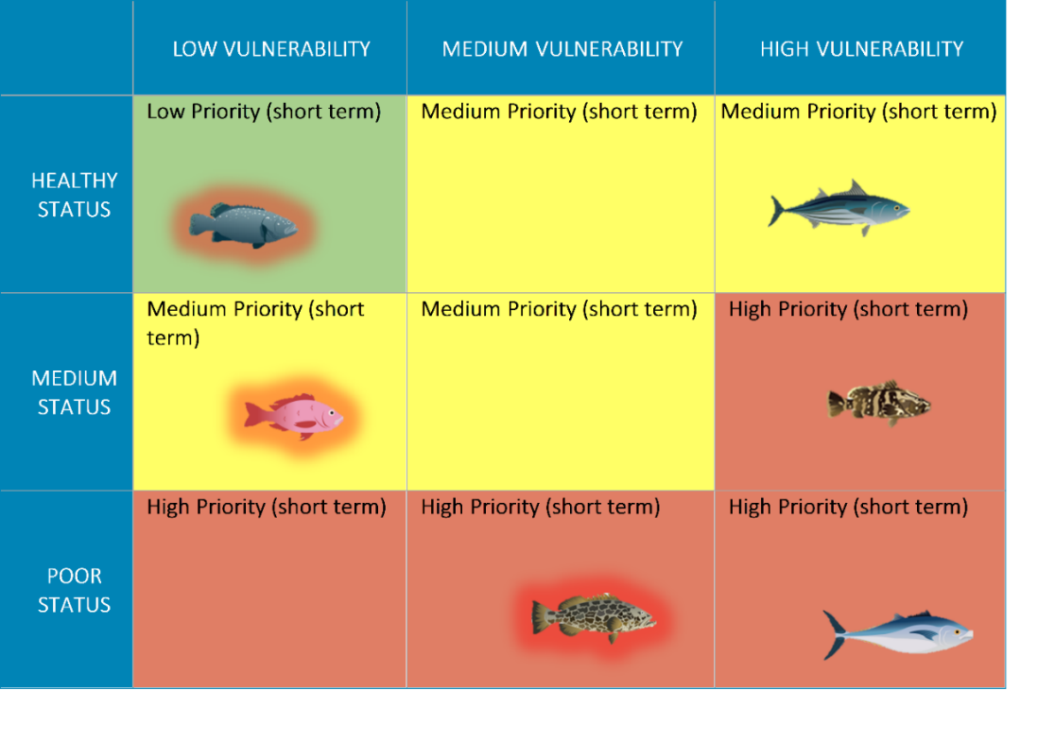

In Table 3a, the three species highlighted in red (the black grouper, silk snapper, and leopard grouper) have been identified as highly vulnerable to climate change. These species should therefore be monitored for indications of expected climate-driven impacts, and climate-relevant management guidance should be developed to be responsive to identified changes in these metrics (see FISHE Steps 7 and 8). In the example above, the two species that fell into the Low and Medium Priority cells based on their current status and vulnerability to the fishery (black grouper and silk snapper) may not be elevated for additional fishery assessments at FISHE Step 9, but they should still be monitored for changes in climate change-related Performance Indicators. Conversely, the leopard grouper was already identified as a High Priority species based on current status and vulnerability to the fishery. This species should therefore be evaluated with the additional FISHE Step 9 assessments to better understand the current impact of the fishery, in addition to evaluating it against climate change-related Performance Indicators.

**FISHE STEP 6, Table 3b**: Incorporating climate vulnerability into prioritization matrix, with fish baskets.

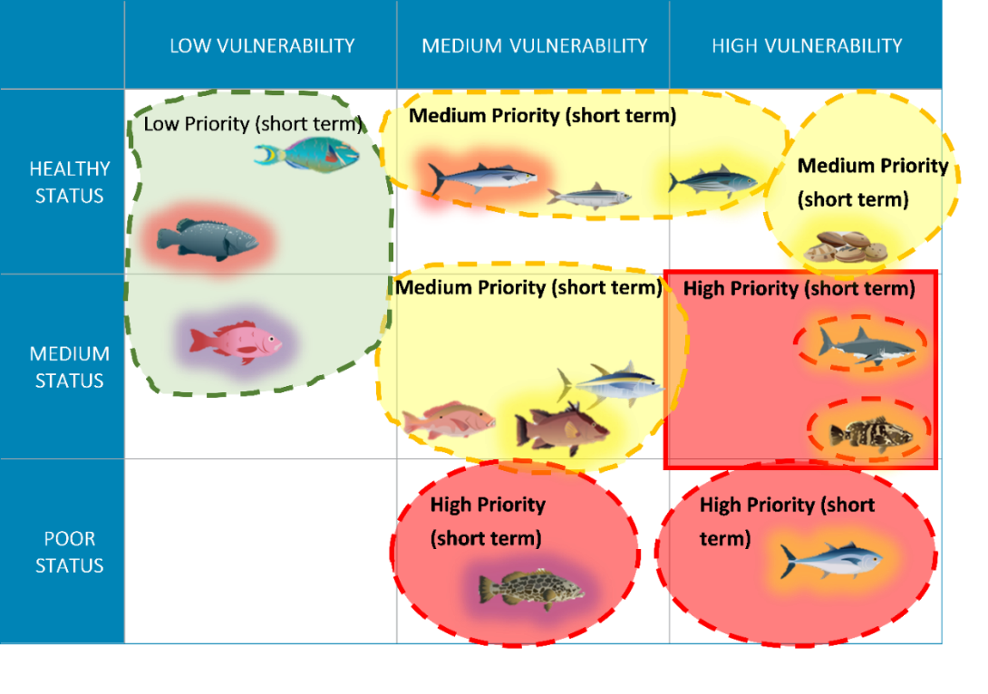

In Table 3b, our hypothetical multispecies fishery, species highlighted in yellow were selected by stakeholders as the representative species for their baskets in the previous part of this process. Species highlighted in red have been identified as especially vulnerable to climate change (and should thus be monitored for indications of these impacts), and species highlighted in purple fall into both categories – they were identified as basket representatives by stakeholders and they are likely to be especially vulnerable to climate change. These two species (silk snapper and leopard grouper) should thus be evaluated with the additional FISHE Step 9 assessments to better understand current impacts of the fishery, as well as monitored for changes in climate-related Performance Indicators (see FISHE Step 7).

Environmental Defense Fund (2021). FISHE Step 1: Projecting future fishery conditions. http://fishe.edf.org/framework/step-1-projecting-future-fishery-conditions. [Accessed April 15, 2021].

Supplemental Text 3. Types of community-based knowledge collected using TEK in the MCAIP Caulín, Northern Patagonia, Chile.

*Participatory mapping***:** this methodology provided information on the spatial distribution of natural banks of target resources, which was contrasted against biological/fishing sampling, finding a high level of overlap in the distribution of natural banks modeled by both methodologies (70%-88% overlap between TEK distribution and fundamental niche; and 40%-90% overlap between realized niche and TEK modeled species distribution). Thus, a better representation of the actual distribution of natural banks in space was achieved. This information was used both for the projection of stocks (quota allocation) and for the design of complementary management measures and control rules.

*Semi-structured interviews*: interviews with community members released historical information about fishing activity and variations in stock distribution and abundance in the MCAIP. These interviews produced a rough estimate of historical landing volumes for resources with underrepresented landing reports and a preliminary feasibility assessment for the implementation of different management measures.

*Focus group***:** the focus group involved diverse members of the local community, representing the different users (e.g., indigenous communities, fishers, divers, and shore harvesting groups) in the territory and allowed Costa Humboldt researchers to validate and adjust the findings obtained through participatory mapping and interviews. The multistakeholder group is characterized by its high degree of knowledge in local traditional practices related to the fishing and cultural operation of the territory, who accompanied by experts that moderated open discussion, identified and selected available scientific information and the fisheries management measures that best suited their fishing situation.

*Biological/fishing sampling***:** the estimation of population density and structure of size and weight of target resource populations within the multispecies fishery was carried out by applying standardized and optimized sampling methods (SUBPESCA, 2021). This information was used for the stock assessment and stock projections, according to current fishery regulations.

SUBPESCA, Resolución Exenta N°355-2021. (2021). Aprueba planes de administración y de manejo y explotación para ECMPO que indica. Accessed January 22, 2021. https://www.subpesca.cl/portal/615/w3-article-109908.html.

Supplemental Figure 1 –The eleven-step FISHE process; starts with projecting likely future fishery conditions, given the expected impacts of climate change. Followed by goals setting, ecosystem assessment, stock vulnerability assessment, initial fishery assessments, prioritization of targets (where the Fish Basket approach resides), the development of performance indicators and reference points, harvest control rules, additional fishery assessments, interpretation, and then implementation and adaption.

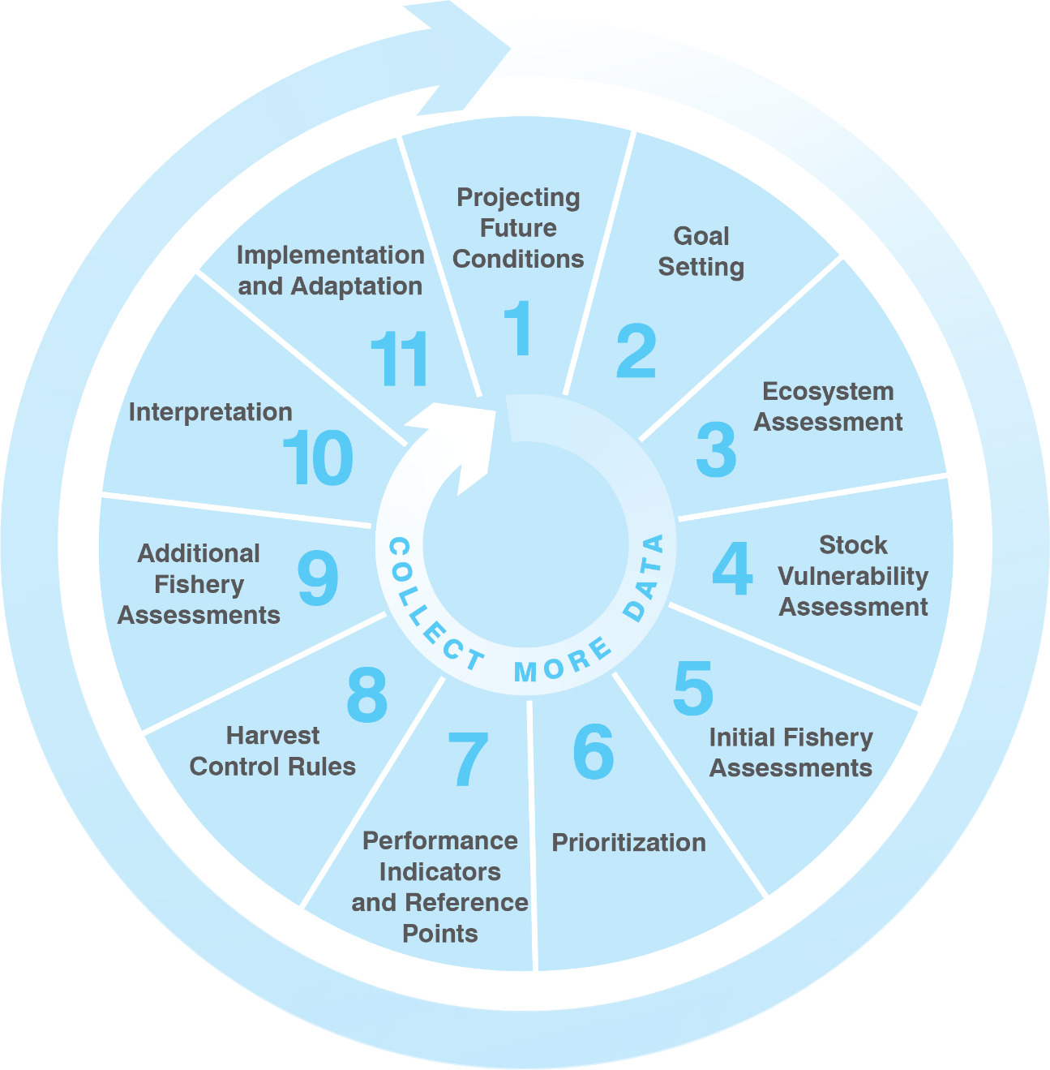

Supplemental Figure 2. Proposed multistakeholder designated fish baskets for the forgotten fish fishery of the Juan Fernández Archipelago and Desventuradas Islands. Individual species, not within a basket are considered others or individual fish baskets.

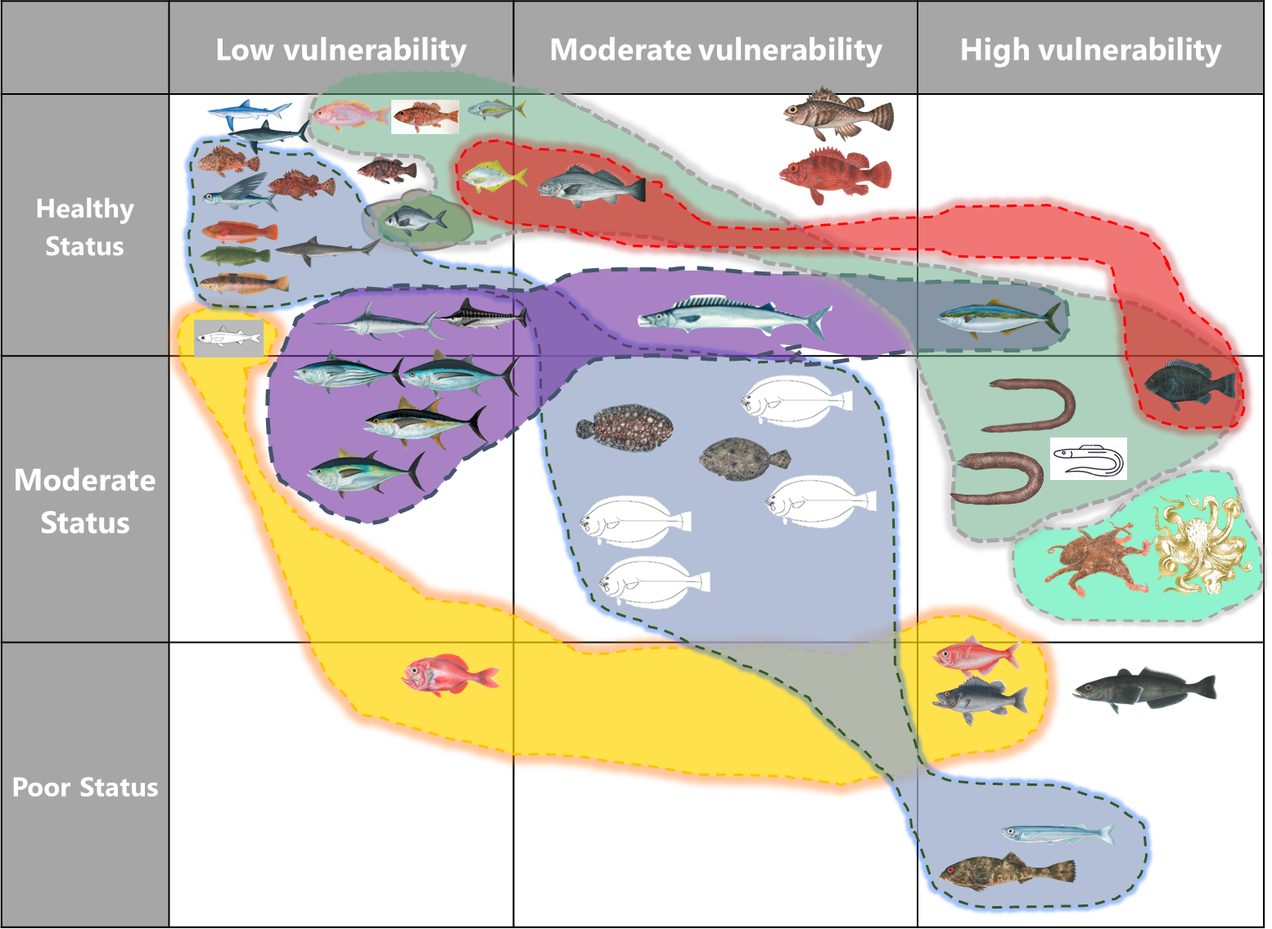

Supplemental Table 1. Small-scale fishing sector of the Yucatan Peninsula and their main characteristics.

|  |  |  |  |  |  |  |  |
| --- | --- | --- | --- | --- | --- | --- | --- |
| Fishery | Species (No.) | Volume (t)(a) | | Value Millions (USD)(a) | | Species with minimum size(b) (Main species) | Status |
| Finfish | 99 | | 27 677 | | 39.67 | *Epinephelus morio* 36.3 cm (LT) | Deteriorate |
| Octopus | 2 | | 14 682 | | 33.89 | *Octopus maya* 11 cm (ML) | Maximum sustainable |
| Shrimp | 7 | | 4440 | | 11.96 | *Xiphopenaeus kroyeri* | Deteriorate |
| Snail | 5 | | 4365 | | 2.42 | *Pleuroplica gigantea* 30 cm (LT) | Deteriorate |
|  |  | |  | |  | *Strombus costatus* 18 cm (LT) |  |
|  |  | |  | |  | *Busycon perversum* 22 cm (LT) | Maximum sustainable |
| Lobster | 2 | | 512 | | 7.04 | *Panulirus argus* 22.3 cm (LT) | Maximum sustainable |
| Shark | 19 | | 2382 | | 2.35 |  | Maximum sustainable |
| Crab | 2 | | 2374 | | 1.88 | Callinectes sp. 110 mm (LT) | Maximum sustainable |
| Sea cucumber | 2 | | 1057 | | 1.42 | *Isostichopus badionotus* 23 cm (LT) | Closed |
| Stone crab | 1 | | 15 | | 0.16 | *Mennippe mercenaria* 70 mm (CL) |  |
| Others |  | | 2897 | | 2.43 |  |  |
| 1. Yearly average values reported between 2006 to 2014 [www.conapesca.com](http://www.conapesca.com)   b. Total length (LT), Mantle length (ML); Total valve length (VL); Chela length (CL) | | | | | | | |

Supplemental Table 2. Other finfish species, specifically snapper and grouper species caught in the red grouper multispecies finfish fishery in the Yucatan, Mexico. Source DOF, 2014.

|  |  |  |
| --- | --- | --- |
| Family | Scientific name | Common name |
| Serranidae | *Epinephelus morio* | Mero rojo, cherna |
| Serranidae | *Epinephelus flavolimbatus* | Mero blanco, extraviado |
| Serranidae | *Hyporthodus nigritus* | Fiat |
| Serranidae | *Epinephelus niveatus* | Cherna pinta |
| Serranidae | *Epinephelus adscensionis* | Payaso verde |
| Serranidae | *Epinephelus guttatus* | Payaso rojo, cabrilla |
| Serranidae | *Epinephelus drummondhayi* | Lenteja |
| Serranidae | *Epinephelus mystacinus* |  |
| Serranidae | *Mycteroperca bonaci* | Negrillo |
| Serranidae | *Mycteroperca interstitialis* | Cabrilla |
| Serranidae | *Mycteroperca phenax* | Gallina |
| Serranidae | *Mycteroperca microlepis* | Abadejo |
| Serranidae | *Mycteroperca venenosa* | Guacamayo |
| Serranidae | *Mycteroperca tigris* | Vampiro |
| Serranidae | *Cephalopholis cruentata* | Cabrilla |
| Lutjanidae | *Lutjanus campechanus* | Huachinango de castilla |
| Lutjanidae | *Lutjanus analis* | Pargo criollo |
| Lutjanidae | *Lutjanus griseus* | Pargo mulato |
| Lutjanidae | *Lutjanus jocu* | Pargo perro |
| Lutjanidae | *Lutjanus synagris* | Biajaiba, pargo biajaiba |
| Lutjanidae | *Ocyurus chrysurus* | rabirrubia, rubia, |
| Lutjanidae | *Rhomboplites aurorubens* | Besugo |
| Malacanthidae | *Lopholatilus chamaeleonticeps* | Corvinato |
| Sparidae | *Calamu ssp.* | Mojaras |
| Carangidae | *Seriola zonata* | Coronado |

Diario Oficial de la Federación (DOF). (2014). ACUERDO por el que Se Da a Conocer El Plan de Manejo Pesquero de Mero (*Epinephelus Morio*) y Especies Asociadas en la Península de Yucatán. SEGOB. Adopted 25 November 2014. <http://extwprlegs1.fao.org/docs/pdf/mex140179.pdf>

Supplemental Table 3. Targets of the multispecies bivalve fishery of Sinaloa, Mexico

|  |  |  |
| --- | --- | --- |
| Fishery | Scientific name | Local Common name |
| AEP Bivalve | *Megapitaria squalida* | Chocolata |
| AEP Bivalve | *Megapitaria aurantiaca* | Chocolata |
| AEP Bivalve | *Chione californiensis* | Chirla |
| AEP Bivalve | *Chione Undatella* | Chirla |
| AEP Bivalve | *Dosinia ponderosa* | Almeja plato |
| AEP Bivalve | *Laevicardium elatum* | Almeja amarilla o Pierna de mujer |
| AEP Bivalve | *Pinna rugosa* | Callo |
| AEP Bivalve | *Atrina maura* | Callo |
| AEP Bivalve | *Atrina tuberculosa* | Callo |
| AEP Bivalve | *Crassostrea iridescens* | Ostiones |
| AEP Bivalve | *Crassotrea corteziensis* | Ostiones |
| AEP Bivalve | *Crassostrea gigas* | Ostiones |
| AEP Bivalve | *Anadara grandis* | Pata de Mula |
| AEP Bivalve | *Anadara tuberculosa* | Pata de Mula |

Supplemental Table 4. Participating stakeholders and activities of the “Sustainable Management of Bivalve Resources through the Implementation of MBD Framed within a Fishery Management Plan of the Altata-Ensenada del Pabellón Lagoon System, Sinaloa”.

|  |  |  |  |  |  |  |  |  |
| --- | --- | --- | --- | --- | --- | --- | --- | --- |
| Participating stakeholders | | | | | | | | |
| **Institution or Organization** | National Comission of Fisheries and Aquaculture (CONAPESCA) | National Institute of Fisheries and Aquaculture (INAPESCA) | Fisheries and Aquaculture Department of the Government of Sinaloa | Sinaloan Institute of Fisheries and Aquaculture (ISAPESCA) | Riparian Fishing Sector of the Lagoon System  (*) | Academic Institutions (**) | Pronatura Noroeste, A.C.  (PNO) | Environmental Defense Fund of México, A.C. (EDF) |
| Ecosystem Management Plan | X Lead of revision, approval and steps for its publication | X Lead of FMP and Implementer | X Participant | X Participant | X Applicant | X Technical Support | X Participant | X Facilitator and Funder |
| Chocolate clam refuge area | X Supporting Technical Study |  | X Technical Support and Installation | X Applicant, Installation of the Refuge and Surveillance |  |  |
| Closed season (veda) of chocolate clam | X Supporting Technical Study |  | X Technical Support | X Applicant and Community Surveillance |  | X Participant |
| FIP chocolate clam*** | X  Participant | X Technical Manager | X Participant | X Participant and Technical Support | X Participant, Technical Support and Implementer | X Participants and Technical Support | X Promoter and Coordinator |
| Stock Research-Assessment Protocol (Monitoring Program) | X Technical Support | X Manager |  | X Technical and Sampling Support | X Applicant and Sampling Support |  |  |
| Fisheries Law and Management Advisory Committee of the Lagoon System | X Executive Department | X Technical Department | X Executive Coordinator | X  Executive Coordinator Member | X Applicant and Spokesperson on the Committee | X Members of the Technical Department | X Guest | X Guest |
| Community Surveillance Program with technical support | X General Manager |  | X Participant and Funder |  | X Applicant and Community Surveillance |  | X Implementer and Funder | X Implementer and Funder |
| Genetic Study |  |  |  |  | X Sample Collection Support | X Study Manager  (1) | X Funder | X Applicant, Logistics Facilitator and Funder |
| Histology Study |  | X Sample Collection and Laboratory Analysis Support |  |  | X Sample Collection Support | X Study Lead | X Funder | X Applicant, Logistics Facilitator and Funder |
| Fisheries Strengthening Program (Strengths and Community Links) |  |  |  |  | X Participants and Technical Support |  |  | X Lead Facilitator, and Funder |
| Market Analysis |  |  |  |  |  |  |  | X Applicant and Funder |
| (*) Riparian Fishing Sector of the Lake System: Federación de Sociedades Cooperativas de Bahía y Aguas Marinas de Altata-Ensenada del Pabellón, S.C. de R.L. de C.V.  Federación de Sociedades Cooperativas y Servicios Turisticos Primera Generación, S.C. de R.L. de C.V. Federación de Sociedades Cooperativas Producción Pesquera Reencuentro Pesquero, S.C. de R.L. de C.V. Coooperativa Almejeras de Santa Cruz Cooperativa Las Lobas del Manglar (**) Faculty of Marine Sciences of the Autonomous University of Sinaloa (FACIMAR-UAS) Interdisciplinary Research Center for Integrated Regional Development of the National Polytechnic Institute - Los Mochis Unit (CIIDIR-IPN) (***) Currently the FIP is specific to the chocolate clam, but we are in the process of transitioning to a multispecies FIP: Chocolata, Chirla and Callo de Hacha (1) University of Arizona | | | | | | | | |

Supplemental Table 5. Current regulations for individual species in the multispecies commercial and subsistence fishery of MCAIP Caulín.

|  |  |  |  |  |  |  |  |
| --- | --- | --- | --- | --- | --- | --- | --- |
| **Fishery type** | **Local common name** | **Species name** | **Closure** | **Seasonal restriction** | **MCS\*** | **TAQ\*** | **Extraction criteria** |
| **Commercial** | Loco | *Concholepas concholepas* | 2 years | Yes | 100 | - | - |
|  | Almeja | *Ameghinomya antiqua* | No | Yes | 55 | Yes | - |
|  | Erizo | *Loxechinus albus* | No | Yes | 70 | Yes | - |
|  | Ostra | *Ostrea chilensis* | 2 years | Yes | 50 | - | - |
|  | Jaiba marmola | *Metacarcinus edwardsii* | No | Only females | 120 | Yes | Yes |
|  | Luga roja | *Gigartina skottsbergii* | No | Yes - hand picking authorized all year | - | - | Yes |
|  | Luga negra | *Sarcothalia crispata* | No | Yes - hand picking authorized all year | - | - | Yes |
|  | Pelillo | *Gracillaria sp.* | No | - | - | - | Yes |
| **Subsistence** | Caracol palo-palo | *Argobuccinum pustulosum* | No | Yes | 75 | - | - |
|  | Caracol negro | *Tegula atra* | No | - | - | - | - |
|  | Culengue | *Gari solida* | No | Yes | 60 | - | - |
|  | Lapa | *Fissurella spp.* | 2 years | Yes | 65 | - | - |
|  | Navajuela | *Tagelus dombeii* | 2 years | Yes | 60 | - | Yes |
|  | Choro | *Mytilus sp.* | No | Yes | 50 | - | - |
|  | Piure | *Piura chilensis* | No | - | - | - | Yes |
|  | Cangrejo | *Taliepus spp.* | No | Only females | 70 | - | - |
|  | Luche | *Pyropia columbina* | No | - | - | - | Yes |
|  | Lamilla | *Ulva spp.* | No | - | - | - | Yes |
|  | Sargazo | *Macrocystis pyrifera* | No | - | - | - | Yes |
| *MCS: Minimum catch size; TAQ: Total allowable quota | | |  |  |  |  |  |

Supplemental Table 6. Target list of the multispecies finfish fishery of Cuba. Those species with a (*) are considered priorities targets for management, and part of the initial scientific assessment tools.

|  |  |  |
| --- | --- | --- |
| **Scientific name** | **Common name - English** | **Common name- Spanish** |
| *Acanthurus coeruleus* | Bluetang | Barbero |
| *Albula vulpes* | Bonefish | Macabi |
| *Archosargus rhomboidalis* | Sea bream | Chopa amarilla |
| *Balistes vetula* | Queen triggerfishe | Cochino |
| *Calamus bajonado* | Jolthead porgy | Bajonao |
| *Caranx hippos* | Crevalle Jack | Jiguagua |
| *Caranx latus* | Horse-eyed jack | Gallego |
| *Caranx ruber* | Bar jack | Cibí |
| *Centropomus undecimalis* | Common snook | Robalo |
| *Diapterus rhombeus \** | Mojarra | Patao |
| *Epinephelus guttatus* | Red hind | Cabrilla |
| *Epinephelus striatus* | Nassau grouper | Cherna criolla |
| *Gerres cinereus* | Yellowfin mojarra | Mojarra rayada |
| *Haemulon sciurus \** | Blue-striped grunt | Ronco amarillo |
| *Harengula clupeola* | False herring, false pilchard | Sardina escamuda |
| *Harengula humeralis* | Redear pilchard, sardine | Sardina de ley |
| *Holocentrus rufus* | Longspine squirrelfish | Carajuelo |
| *Lachnolaimus maximus* | Hogfish | Pez perro |
| *Lutjanus analis \** | Mutton snapper | Pargo criollo |
| *Lutjanus apodus* | Schoolmaster snapper | Caji |
| *Lutjanus cyanopterus* | Cubera snapper | Cubera |
| *Lutjanus griseus* | Grey snapper | Caballerote |
| *Lutjanus jocu* | Dog snapper | Jocú |
| *Lutjanus synagris \** | Lane snapper | Biajaiba |
| *Megalops atlanticus \** | Sábalo | Tarpon |
| *Mugil curema \** | White mullet | Liseta |
| *Mugil liza* | Grey mullet | Lisa |
| *Ocyurus chrysurus* | Yellowtail snapper | Rubia |
| *Ophistonema oglynum \** | Atlantic thread herring | Machuelo |
| *Pseudopeneus maculatus* | Spotted goatfish | Salmonete |
| *Scarus vetula* | Queen parrotfish | Loro |
| *Scomberomorus cavalla* | King mackerel * | Sierra |
| *Selar crumehopthalmus \** | Bigeye scad | Chicharro |
| *Tarpon atlanticus* | Tarpon | Sábalo |
| *Trachinotus goodei* | Permit | Palometa |

Supplemental Table 7. Targets for the forgotten fish multispecies fisheries management plans of the Juan Fernández Archipelago and Desventuradas Islands (JR and DI) and the Los Ríos (LR) regions.

|  |  |  |
| --- | --- | --- |
| **Region** | **Scientific name** | **Common name** |
| JF and DI | *Arnoglossus coeruleostica* | Lenguado sp |
| JF and DI | *Aseraggodes bahamondei* | Lenguado sp |
| JF and DI | *Beryx splendens* | Alfonsino |
| JF and DI | *Caprodon longimanus* | Graniento |
| JF and DI | *Chironemus delfini* | Cabrilla de Juan Fernandez |
| JF and DI | *Dissostichus eleginoides* | Mero |
| JF and DI | *Exocoetus volitans* | Pez volador |
| JF and DI | *Girella albostriata* | Jerguilla de Juan Fernandez |
| JF and DI | *Gymnothorax australicola* | Morena sp |
| JF and DI | *Gymnothorax cf.obesus* | Morena sp |
| JF and DI | *Helicolenus lengerichi* | Chancharro |
| JF and DI | *Hoplostethus atlanticus* | Orange roughy |
| JF and DI | *Isurus oxyrinchus* | Mako |
| JF and DI | *Kajikia audax.* | Marlyn rayado |
| JF and DI | *Katsuwonus pelamis* | Atun listado |
| JF and DI | *Malapterus reticulatus* | Vieja |
| JF and DI | *Maxillicosta reticulata/Scorpaenodes englerti* | Chancharro de Juan Fernandez |
| JF and DI | *Muranichtys chilensis* | Morena sp |
| JF and DI | *Nemadactylus gayi* | Breca |
| JF and DI | *Octopus crusoe* | Pulpo de Juan Fernandez |
| JF and DI | *Octopus selkirk* | Pulpo |
| JF and DI | *Odontesthes gracilis* | Pejerrey |
| JF and DI | *Paralichthys coeruleostica* | Lenguado sp |
| JF and DI | *Paralichthys fernandezianus* | Lenguado |
| JF and DI | *Paralichthys hilgendorfi* | Lenguado sp |
| JF and DI | *Paralichthys schmitti* | Lenguado sp |
| JF and DI | *Plagiogeneion sp.* | Colorado |
| JF and DI | *Polyprion oxigeneios* | Bacalao de Juan Fernandez |
| JF and DI | *Prionace glauca* | Azulejo |
| JF and DI | *Pseudocaranx chilensis* | Jurel de Juan Fernandez (Jurelillo) |
| JF and DI | *Pseudolabrus gayi* | Vieja |
| JF and DI | *Scorpaena Fernandeziana* | Pez escorpión |
| JF and DI | *Scorpaena thomsoni_* | Pez escorpión/ pez piedra |
| JF and DI | *Scorpis chilensis* | Pampanito |
| JF and DI | *Seriola lalandi* | Vidriola |
| JF and DI | *Sicyases brevirostris* | Pejesapo de Juan Fernandez |
| JF and DI | *Squalus mitsukurii* | Tollo |
| JF and DI | *Suezichthys rosenblatti* | Vieja |
| JF and DI | *Thunnus alalunga* | Atun aleta larga |
| JF and DI | *Thunnus albacares* | Atun aleta amarilla |
| JF and DI | *Thunnus obesus* | Atun ojos grandes |
| JF and DI | *Thyrsites atun* | Sierra |
| JF and DI | *Umbrina reedi* | Corvina de Juan Fernandez |
| JF and DI | *Xiphias gladius* | Albacora |
| Los Ríos | *Thyrsites aun* | Sierra |
| Los Ríos | *Cilus gilberti* | Corvina |
| Los Ríos | *Allthunnus falla* | Atun Lanzon |
| Los Ríos | *Trachurus murphyi* | Jurel |
| Los Ríos | *Odonthestes regia* | Pejerrey |
| Los Ríos | *Oncorhynus tshawytscha* | Salmon chinook |